**About us**

Keyraya embodies a vibrant team driven by a unified purpose Top of Form

: to revolutionize mobility solutions in India. Our relentless focus has propelled us to create a cutting-edge platform offering rentals across Bengaluru recognizing the vast potential in the largely unexplored and disorganized transportation sector, we are driven to establish a trusted system that transcends barriers for all.

At Keyraya, we pride ourselves on our unrestricted approach to two-wheelers, catering to every need from everyday scooters to exhilarating superbikes. Our services are easily accessible through both our website and mobile application, ensuring seamless rental experiences for our customers.

Central to our ethos is the belief in the power of renting over buying. We believe in the idea of "Cruise without commitment: Ride when you want, return when you're done." offering unparalleled convenience and flexibility to our users.

Join us on our journey as we redefine mobility solutions and pave the way for a future where renting is not just a choice but a lifestyle.

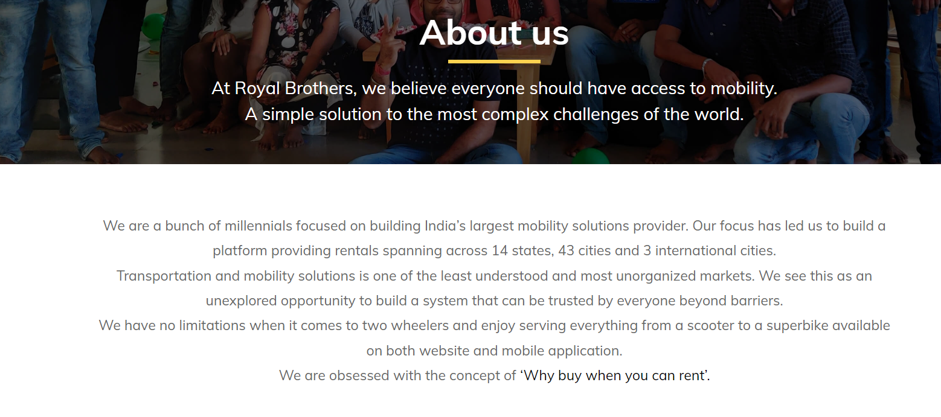

**Privacy Policy**

This Privacy Policy constitutes an electronic record serving as an electronic contract established under the Information Technology Act, 2000, along with the associated regulations and amended provisions concerning electronic documents/records within various statutes, as altered by the Information Technology Act, 2000, or any relevant statute or regulation under any applicable jurisdiction. It is to be noted that this Privacy Policy does not necessitate any physical, electronic, or digital signature.

The objective of this Privacy Policy is to establish a comprehensive framework for the collection, utilization, and safeguarding of any personal and/or sensitive data obtained by us. It delineates our protocols for the collection, utilization, processing, disclosure, and protection of any information obtained through the Platform. Any terms capitalized in this Privacy Policy, not defined herein, shall carry the same meaning ascribed to them in our Terms of Service. Any reference to the Privacy Policy in this document shall imply and pertain to the latest version of the Privacy Policy.

Consent:

This Privacy Policy constitutes a legally binding agreement between you and the Company. The terms delineated herein shall become effective upon your acceptance of the same or through your utilization of our services, thereby governing the relationship between the Company and you concerning your use of the Platform and our services.

By utilizing this Platform and availing our services, you signify that you comprehend, agree to, and consent to this Privacy Policy. In the event that you disagree with the terms of this Privacy Policy, kindly refrain from using this website or availing our services.

Please note that any Information acquired by us shall be:

* Processed fairly and lawfully for rendering the Services;
* Obtained solely for specified and lawful purposes;
* Adequate, relevant, and not excessive concerning the purpose for which it is required;
* Able to be reviewed by the User periodically and updated as necessary; and
* Not retained longer than necessary for the intended purpose or as mandated by applicable law.

Should you disagree with this Privacy Policy, you reserve the right to refuse or withdraw your consent at any time. Alternatively, you may choose not to provide us with any Personal Information. It is understood that under such circumstances, we may be unable to render Services. Any such notification to withdraw your consent can be directed to keyraya.info@gmail.com.

Liability Disclaimer:

We shall not be held liable for any loss or damage sustained due to any disclosure (whether inadvertent or otherwise) of any data, if such disclosure: (A) Is necessary for sharing your information for legitimate purposes; or (B) Occurs through no fault, act, or omission of the Company.

For the full privacy policy, visit our website or contact our support team.

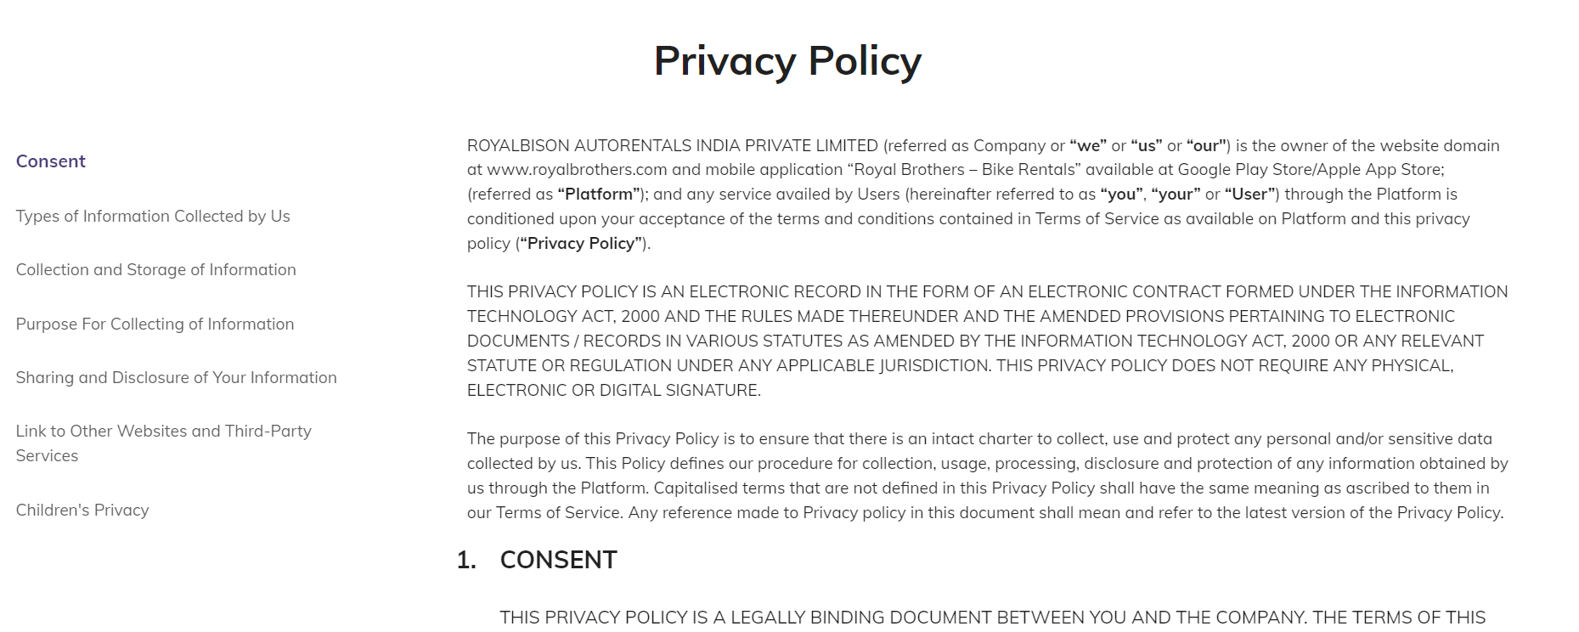

**Contact Us/ Reach Us**

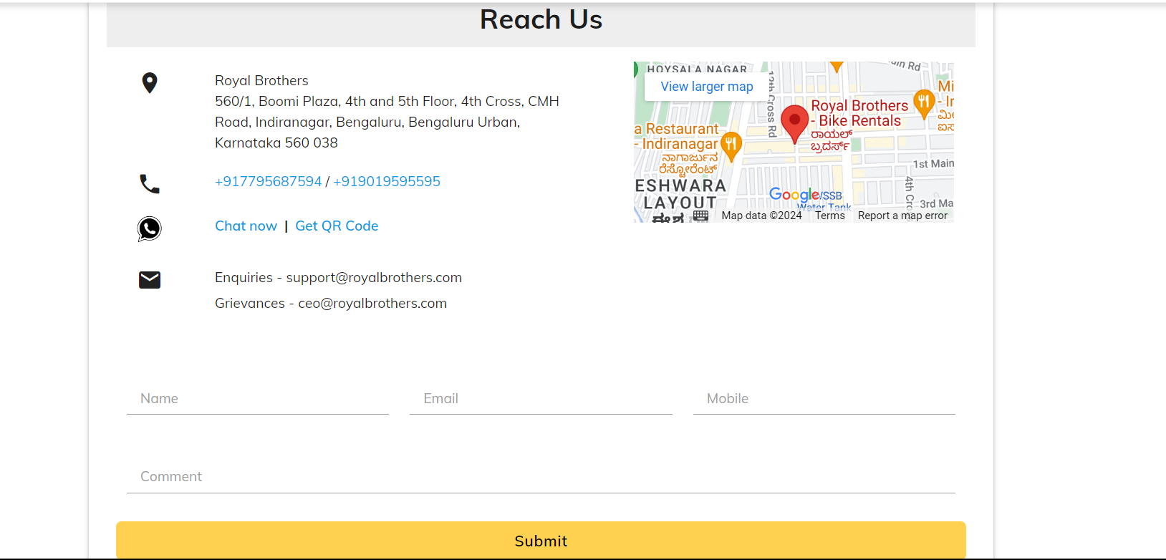

Address - Keyraya

Nagasandra, near Tumkur Road,

Bengaluru,

Karnataka 560073

Phone - 7969760909

Email - keyraya.info@gmail.com